# Evaluation Rubric :

|  |  |  |
| --- | --- | --- |
| **Evaluation parameter** | **Does not meet specifications** | **Meets specifications** |
| **Problem statement** |  |  |
| Problem Statement must be clearly defined |  |  |
| Expected input and output formats must be described |  |  |
| Explain the problem statement with an example(if applicable) |  |  |
| **Expected input & output** |  |  |
| Minimum of 5 test cases (if applicable) |  |  |
| Coverage |  |  |
| Border condition |  |  |
| Unexpected inputs |  |  |
| **Solution** |  |  |
| The correctness of the solution. |  |  |
| Check for all the elements (tokens) of the problem (Assignment, Arithmetic, conditional, relational, input, output etc) |  |  |
| **Trace Table :** |  |  |
| Columns are variables, conditions, print statements |  |  |
| Order |  |  |
| Trace table for each function(If applicable) |  |  |
| labeling the columns |  |  |
| Coverage (conditions, iterations... etc) |  |  |
| **Final Result** |  |  |
| Executable File Submission |  |  |
| **Executable File** |  |  |
| Check with all test cases |  |  |

# 

**Problem Statement**: **(2 Marks)**

Print the following series based on the value of N For Example: If N is 4

1

2 3

3 4 5

4 5 6 7

**Test cases: (3 Marks)**

|  |  |
| --- | --- |
| **Expected Input** | **Expected Output** |
| n=4  1  2 3  3 4 5  4 5 6 7 | True |
| n=2  1  2 3 | True |
| n=3  1  2 3  3 4 5 | True |

**Solution**: **(5 Marks)**

**Step 1:** START

**Trace Table** :

**Test case 1: n=2 (5 Marks)**

|  |  |  |  |  |  |  |  |  |  |  |
| --- | --- | --- | --- | --- | --- | --- | --- | --- | --- | --- |
| N | i | i<=N | k=i | i++ | j | j<=i | j++ | k++ | o/p | \n |
| 2 | 1 | 1<=1 | 1 |  | 1 | 1<=1 |  |  | 1 |  |
|  |  |  |  | 2 |  |  |  |  |  | \n |
|  | 2 | 2<=2 | 2 |  | 1 | 1<=2 | 2 | 3 | 2 |  |
|  |  |  |  | 3 |  |  |  |  |  |  |
|  | 3 | 3<=2 | 3 |  | 2 | 2<=3 | 3 | 4 | 3 |  |
|  |  |  |  | 4 |  |  |  |  |  |  |
|  | 4 | 4<=2 | 4 |  | 3 | 3<=3 | 4 | 5 | 1 \n 2 3 |  |

Test Case 2: n=3

|  |  |  |  |  |  |  |  |  |  |
| --- | --- | --- | --- | --- | --- | --- | --- | --- | --- |
| n | i | i<=n | i++ | k=i | j | j<=i | j++ | k++ | o/p k |
| 3 | 1 | i<=3 |  | 1 |  |  |  |  | 1 \n |
|  |  |  | 2 |  | 1 | 1<=2 |  |  | 1 \n _ |
|  | 2 | 2<=3 |  | 2 |  |  | 2 | 2 | 1 \n _2 |
|  |  |  | 3 |  | 2 | 2<=3 |  |  | 1\n 2 3 |
|  | 3 | 3<=3 |  | 3 |  |  | 3 | 3 | 1\n 2 3_ |
|  |  |  | 4 |  | 3 | 3<=4 |  |  | 1\n 2 3_ \n |
|  | 4 | 4<=3 |  | 4 |  |  |  |  | 1\n 2 3\n 3 |
|  |  |  | 5 |  | 4 | 4<=5 | 4 | 4 | 1\n 2 3\n 3_ 4 |
|  |  |  |  |  |  |  |  |  | 1\n 2 3 \n 3_4_ |
|  |  |  |  |  | 5 | 5<=5 | 5 | 5 | 1\n 2 3 \n 3_4_5 |
|  |  |  |  |  |  |  |  |  | 1\n 2 3 \n 3_4_5 |
|  |  |  |  |  | 6 | 6<=5 | 6 | 6 |  |

Test case 3: n=4

|  |  |  |  |  |  |  |  |  |  |  |
| --- | --- | --- | --- | --- | --- | --- | --- | --- | --- | --- |
| n | i | i<=n | i++ | k=i | j | j<=i | j++ | k++ | o/p k |  |
| 4 | 1 | i<=4 |  | 1 |  |  |  |  | 1 \n |  |
|  |  |  | 2 |  | 1 | 1<=2 |  |  | 1 \n _ |  |
|  | 2 | 2<=4 |  | 2 |  |  | 2 | 2 | 1 \n _2 |  |
|  |  |  | 3 |  | 2 | 2<=3 |  |  | 1\n 2 3 |  |
|  | 3 | 3<=4 |  | 3 |  |  | 3 | 3 | 1\n 2 3_ |  |
|  |  |  | 4 |  | 3 | 3<=4 |  |  | 1\n 2 3_ \n |  |
|  | 4 | 4<=4 |  | 4 |  |  |  |  | 1\n 2 3\n 3 |  |
|  |  |  | 5 |  | 4 | 4<=5 | 4 | 4 | 1\n 2 3\n 3_ 4 |  |
|  | 5 | 5<=4 |  | 5 |  |  |  |  | 1\n 2 3 \n 3_4_ |  |
|  |  |  | 6 |  | 5 | 5<=6 |  |  | 1\n 2 3 \n 3_4_5 |  |
|  |  | 6<=4 |  | 6 |  |  | 5 | 5 | 1\n 2 3 \n 3_4_5 \n |  |
|  |  |  | 7 |  | 6 | 6<=7 |  |  | 1\n 2 3 \n 3_4_5 \n 4 |  |
|  |  |  |  | 7 |  |  | 6 | 6 | 1\n 2 3 \n 3_4_5 \n 4_ |  |
|  |  |  | 8 |  | 7 | 7<=8 |  |  | 1\n 2 3 \n 3_4_5 \n 4_5 |  |
|  |  |  |  | 8 |  |  | 7 | 7 | 1\n 2 3 \n 3_4_5 \n 4_5_6 |  |
|  |  |  |  |  | 8 | 8<=8 |  |  | 1\n 2 3 \n 3_4_5 \n 4_5_6_ |  |
|  |  |  |  |  |  |  |  |  | 1\n 2 3 \n 3_4_5 \n 4_5_6_7 |  |

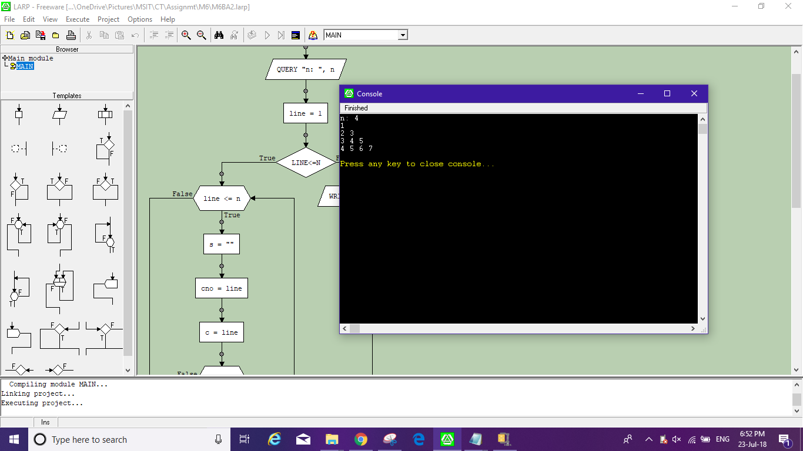

**Final Result :** **(2 Marks)**

|  |  |  |  |
| --- | --- | --- | --- |
| **Expected input** | **Expected output** | **Actual output** | **Test result** |
| n=4  1  2 3  3 4 5  4 5 6 7 | True | 1  2 3  3 4 5  4 5 6 7 | 1 |
| n=2  1  2 3 | True | 1  2 3 | 1 |
| n=3  1  2 3  3 4 5 | True | 1  2 3  3 4 5 | 1 |